Lab: Code Versioning Using GitHub
INFO29760 Hardware Troubleshooting Maintenance (A+ Certification Prep)
Purpose: For this lab, I will be walking through the installation of Git, creating a repository on GitHub, downloading an extension for VS Code so that GitHub will work, and I can transfer my repository from GitHub to VS Code. GitHub is a site in which developers store their projects of lines of code and such while sharing and networking this to many people.
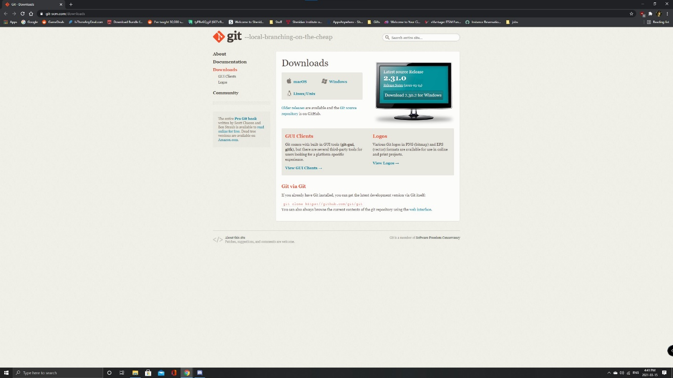 | The first step for this lab is to download Git.  To download Git, go to:  https://git-scm.com/downloads  Make sure to select the correct installation for your operating system.
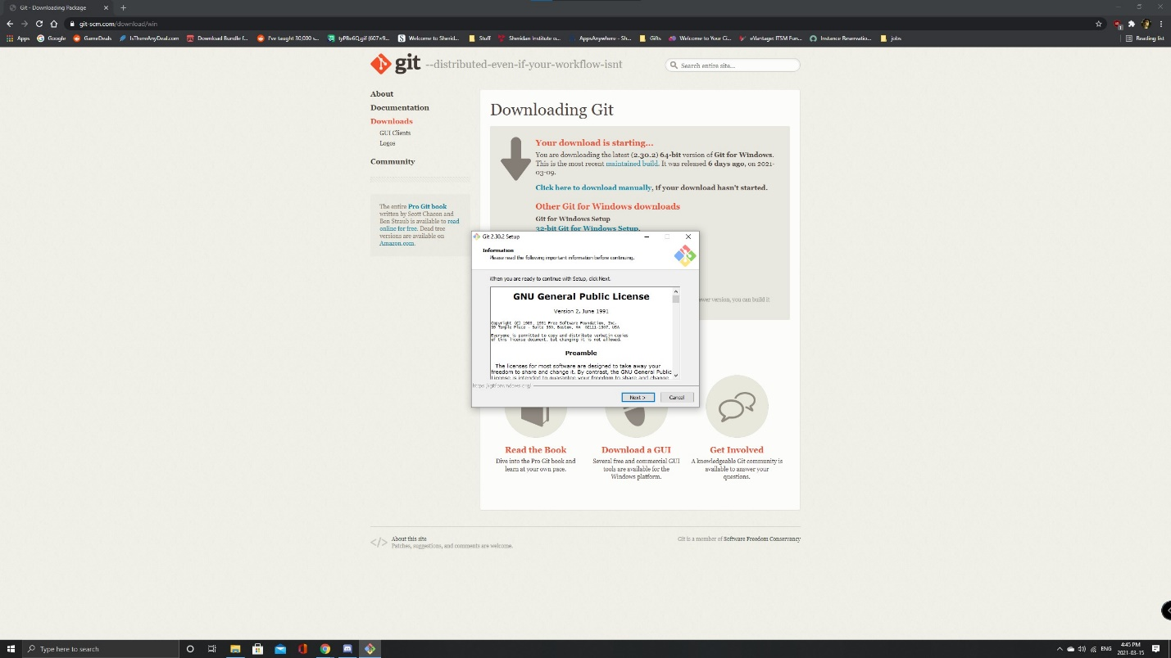 | Once the installation wizard opens, make sure to follow the on-screen instructions as there is not too much to tweak.
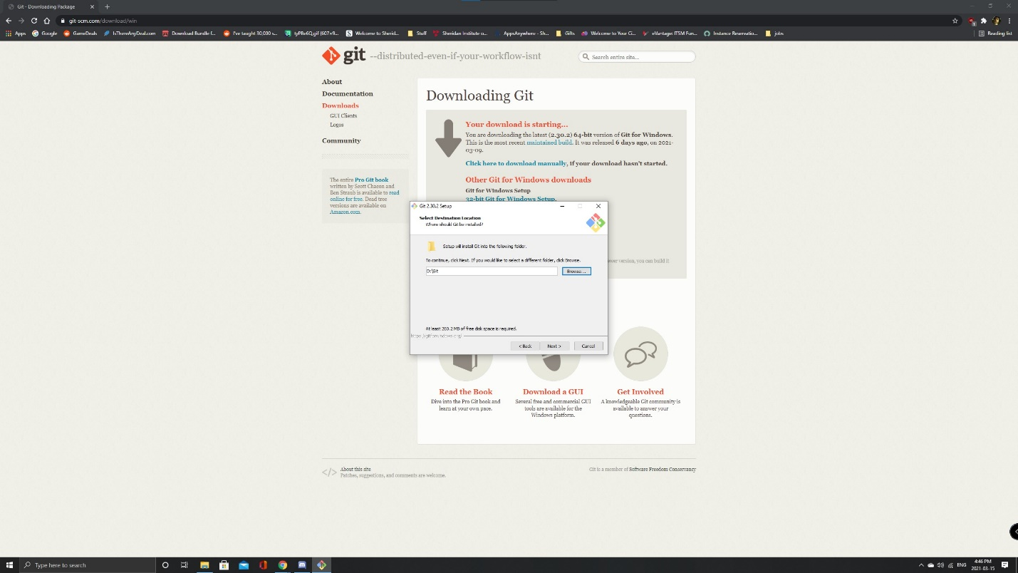 | If you would like to change the destination location of Git, you can select Browse and pick any location you want or leave it as default.
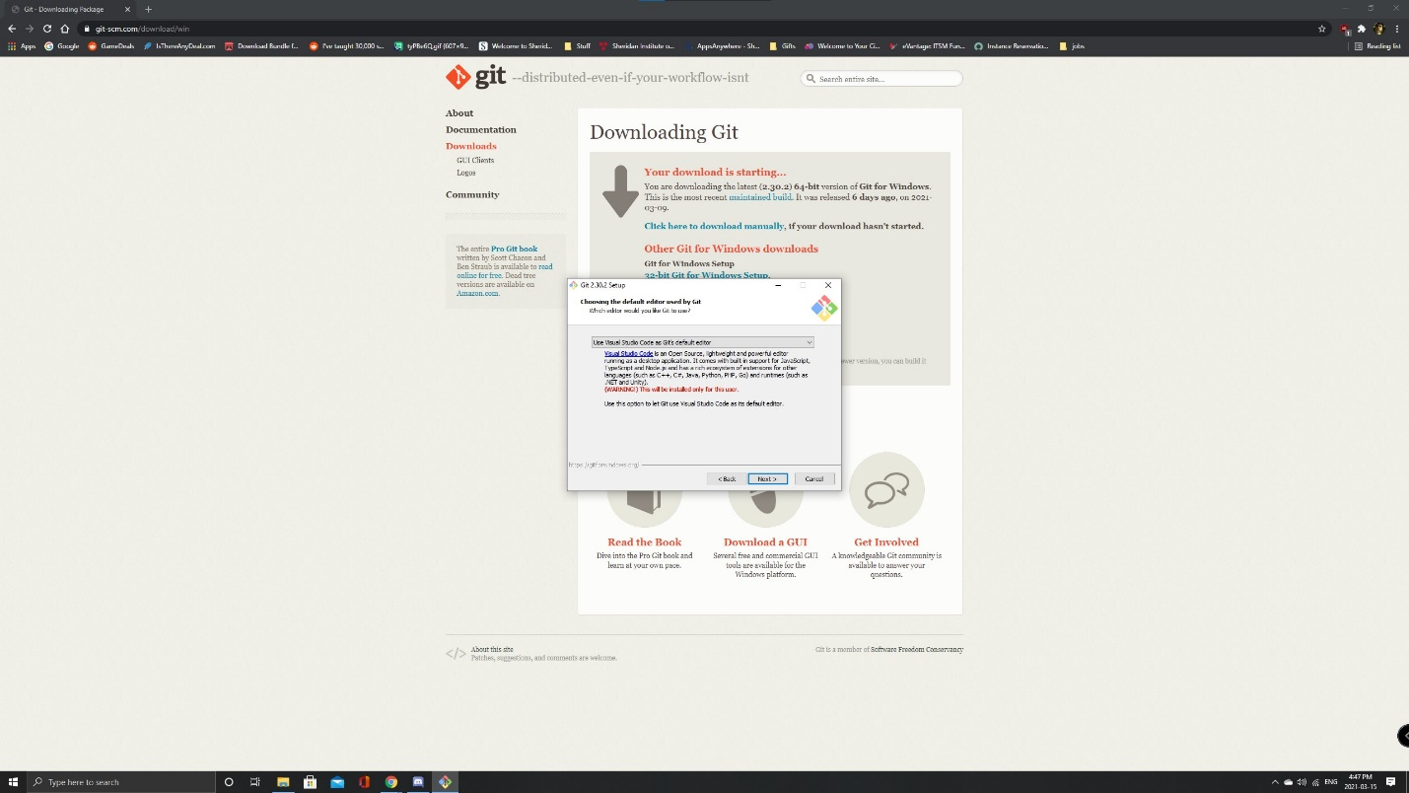 | Once you are on this part, it is important to select Use Visual Studio Code as Git’s default editor so that it will work with VS Code.  Click Next to continue.
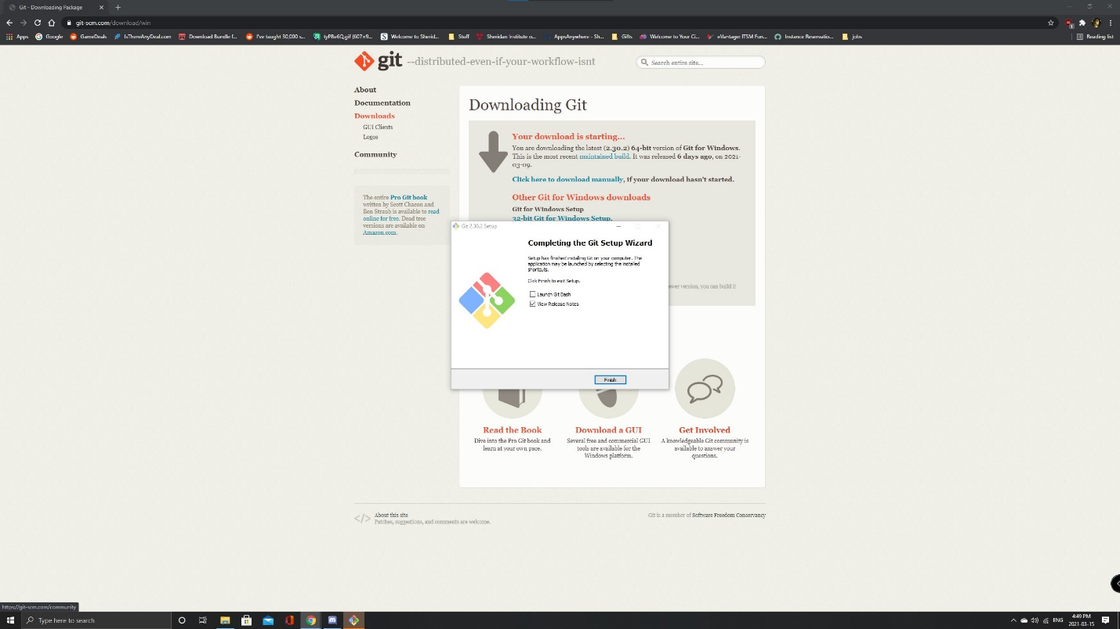 | Once the installation is complete, click on Finish.
 | Once Git is downloaded, the next step is to go to GitHub.com and to sign up and create an account.
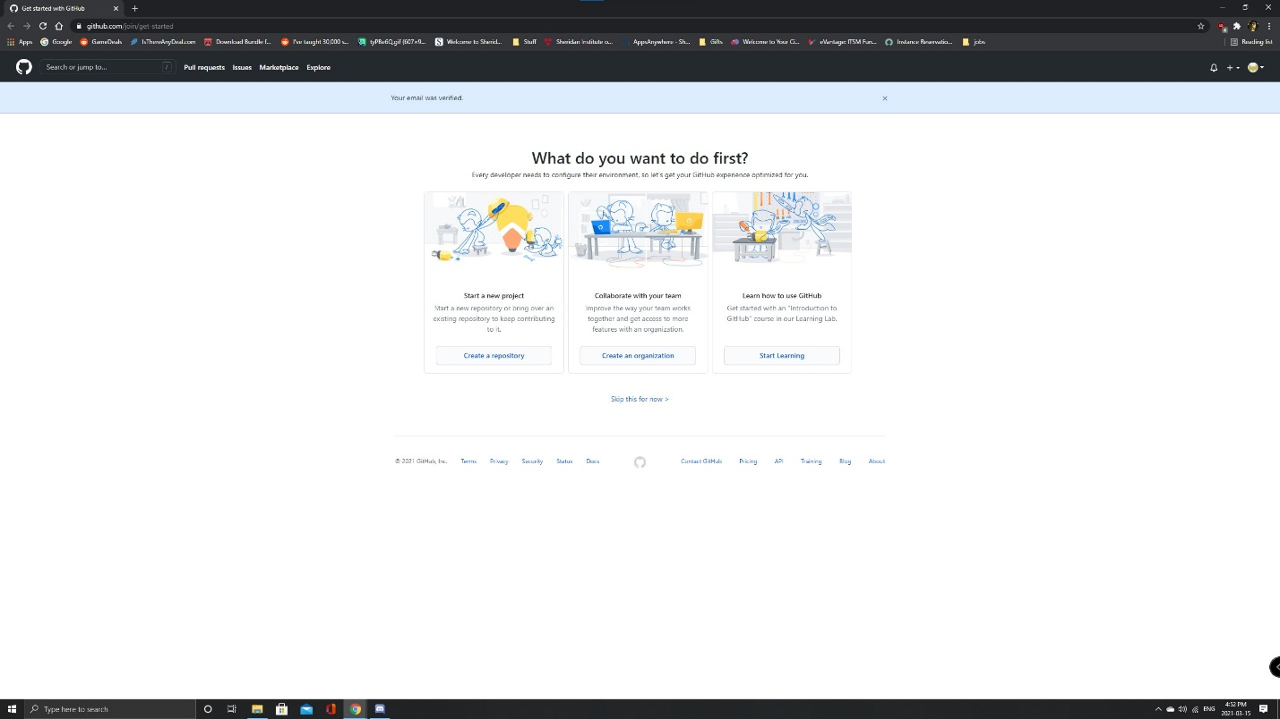 | After signing up and verifying your email account, you will be brought to this screen.  Make sure to click on Create a repository.  A repository is the location for where all files for a particular project is stored.
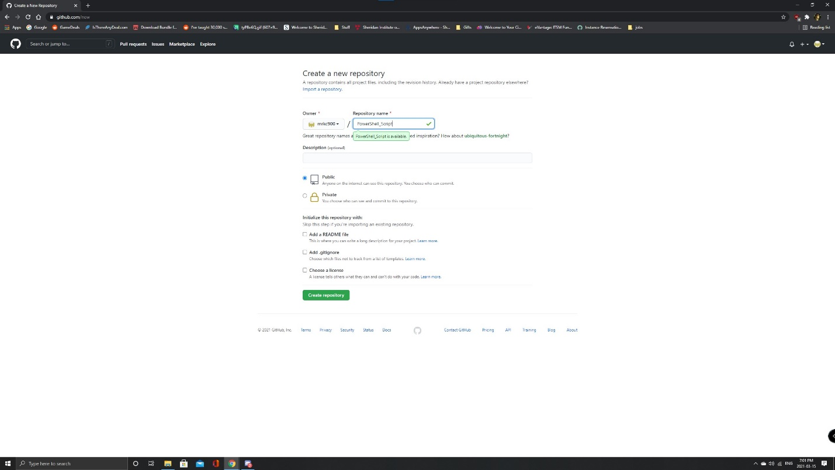 | Under Repository name, make sure to name it PowerShell_Script.  Click on Create repository to continue.
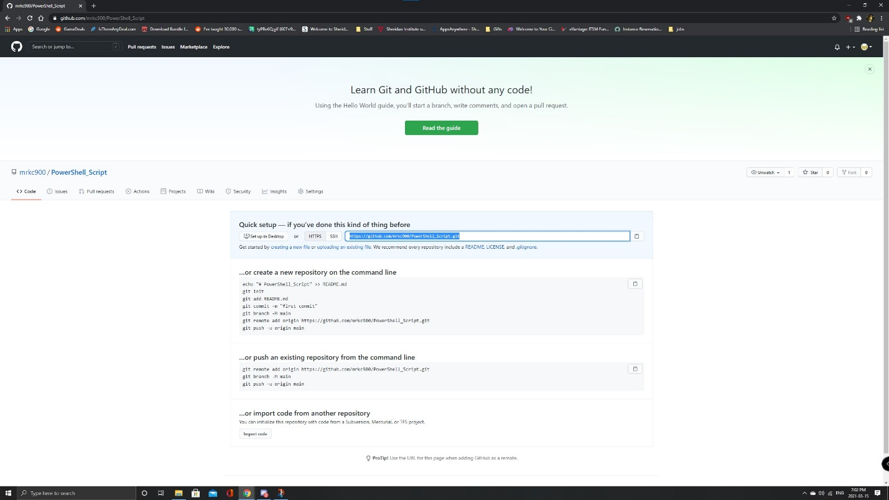 | The repository is now complete and ready to be used in VS Code.
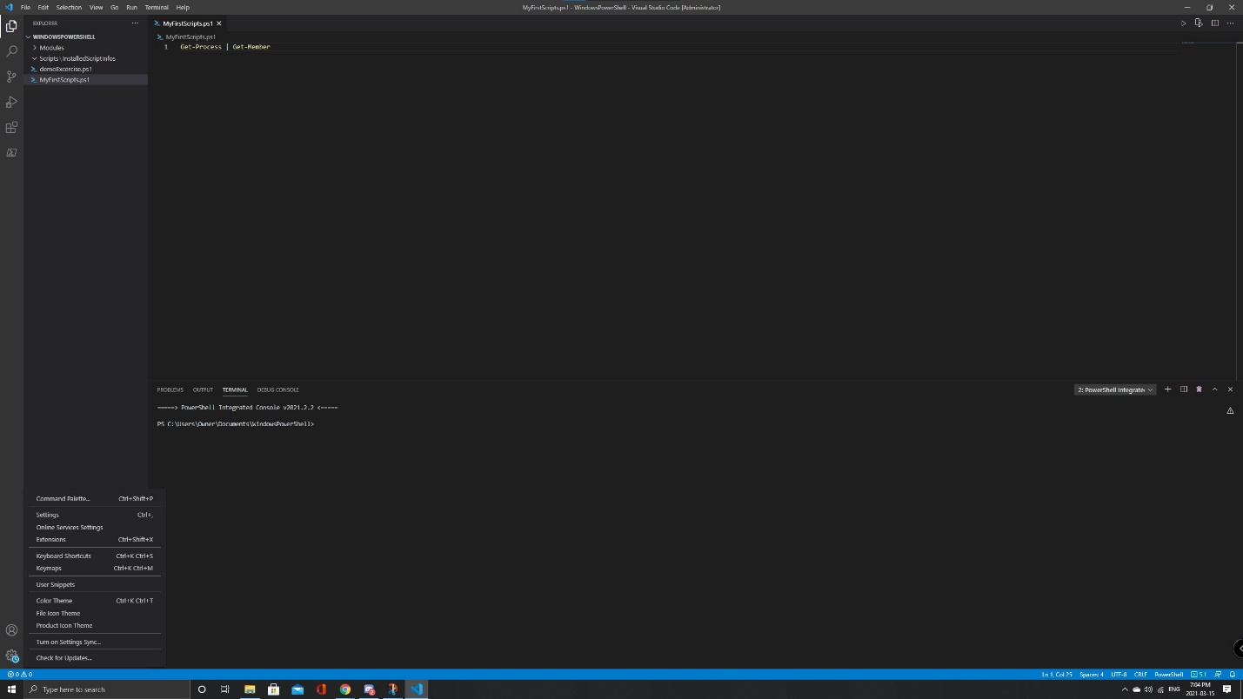 | With the repository made, Launch VS Code and go to settings to enable Git.
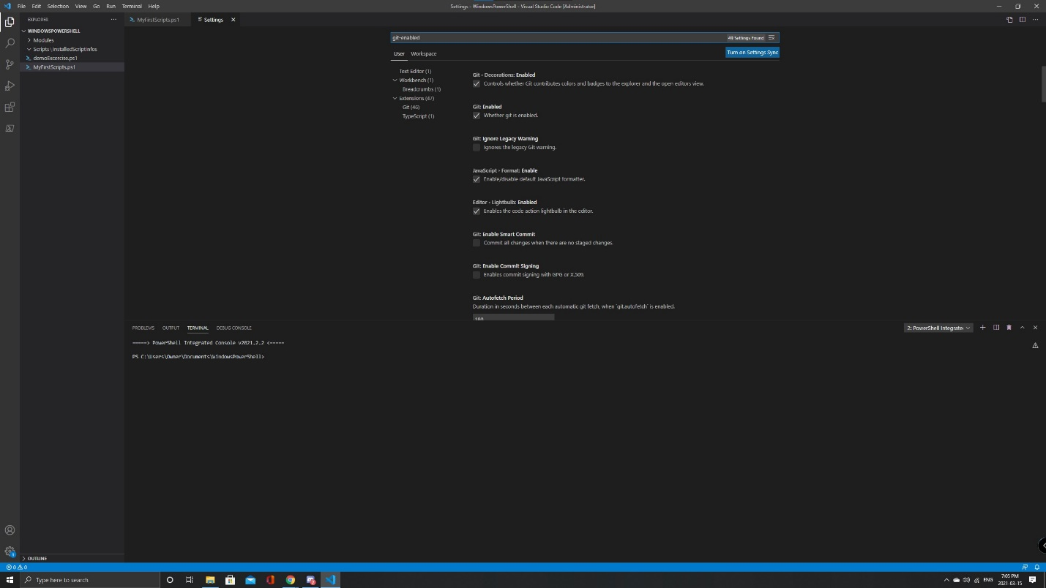 | In the search bar, type: git-enabled and a list should appear.  Look for Git: Enabled and make sure to check mark the box.
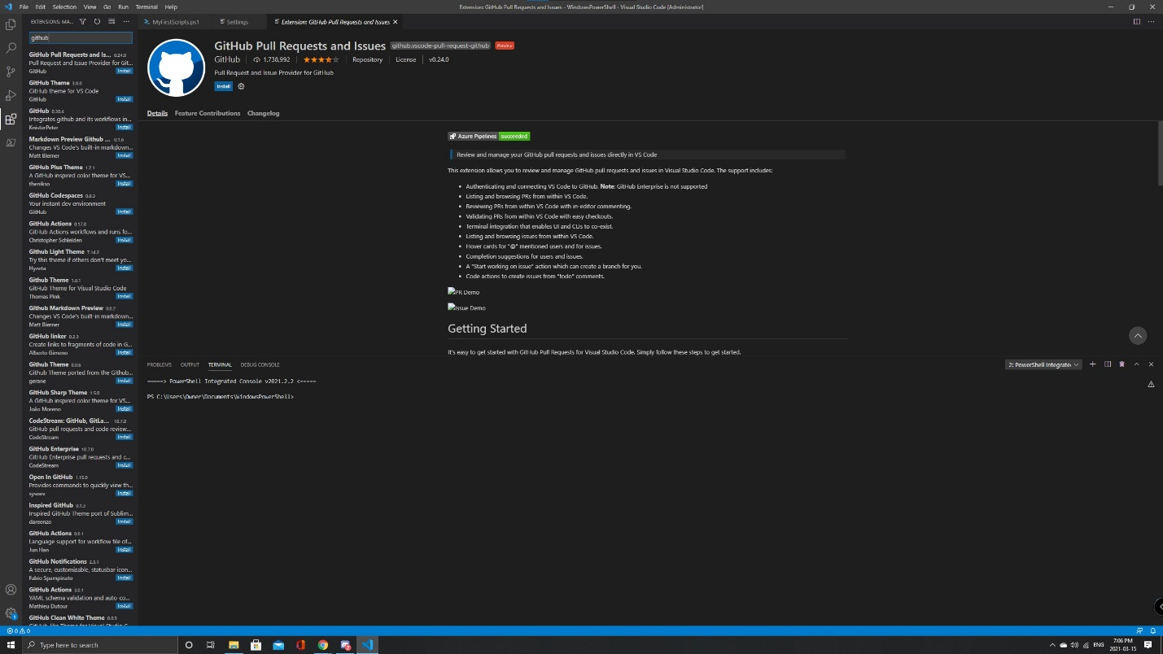 | Once Git is enabled, go to the extensions page, and look up GitHub.  Click on the first result that says GitHub Pull Requests and Issues and click on Install.
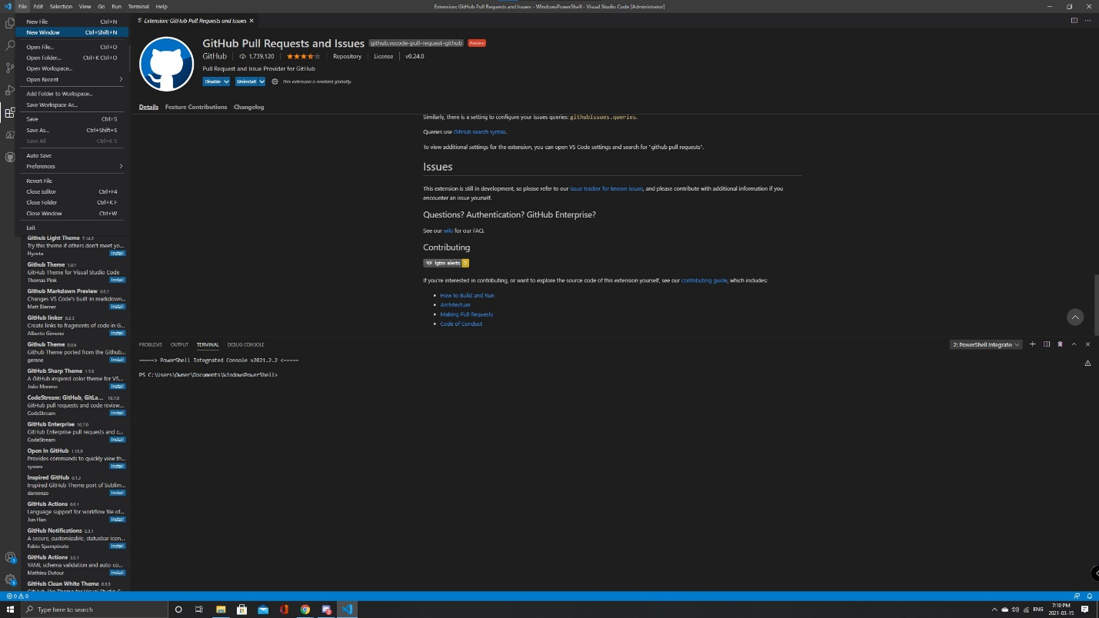 | After the installation, go to File>New Window to prepare to clone the repository from GitHub.
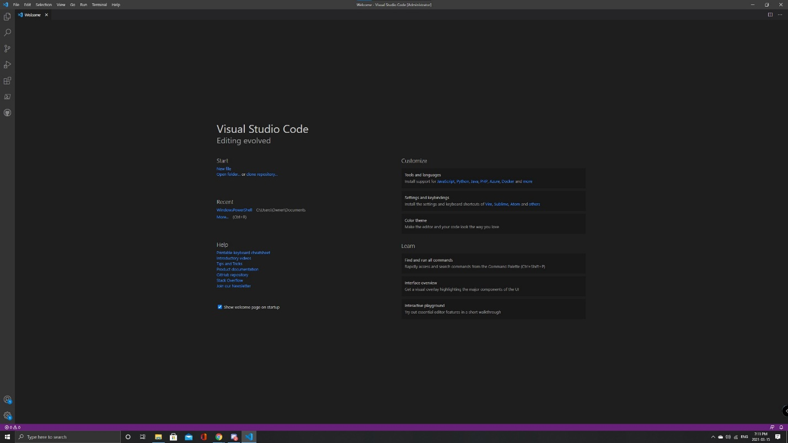 | When the new window opens you will be brought to a welcome page.  Below Start click on Clone Repository.
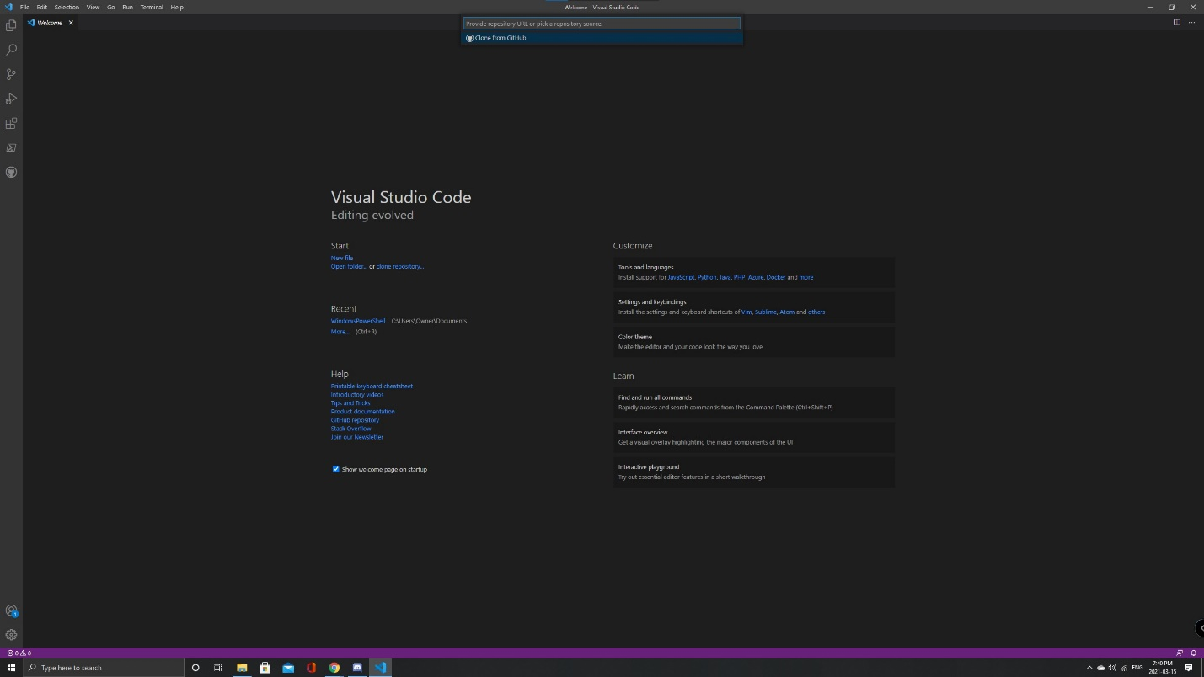 | A search bar should appear at the top of the window with Clone from GitHub as a clickable option.  Click on it.
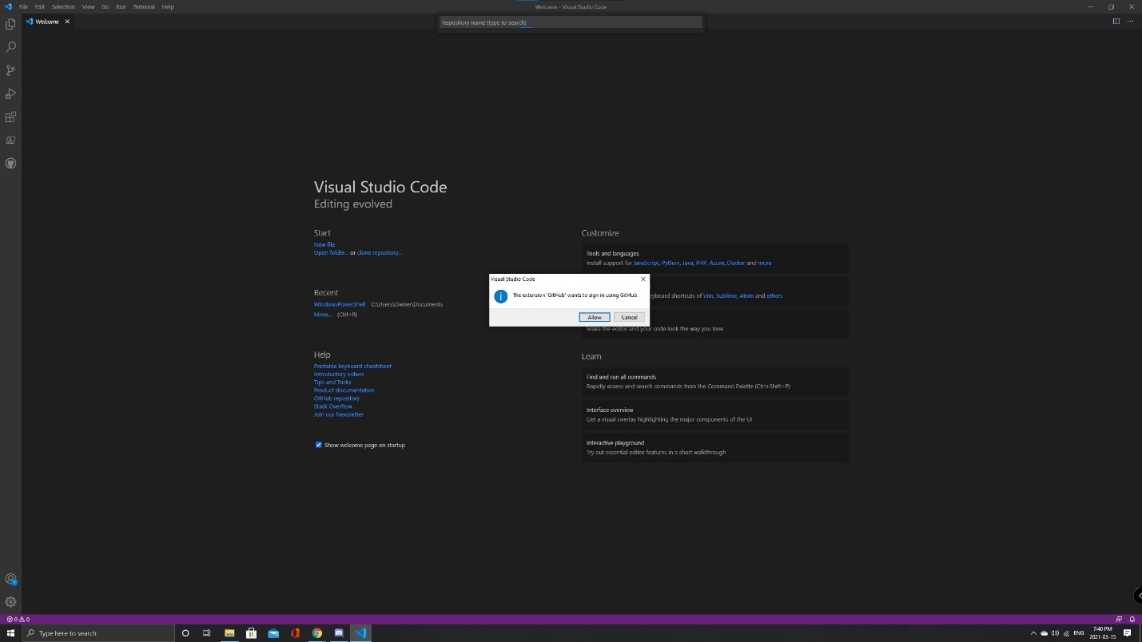 | A notification will pop up asking to sign in using GitHub.  Click on Allow.
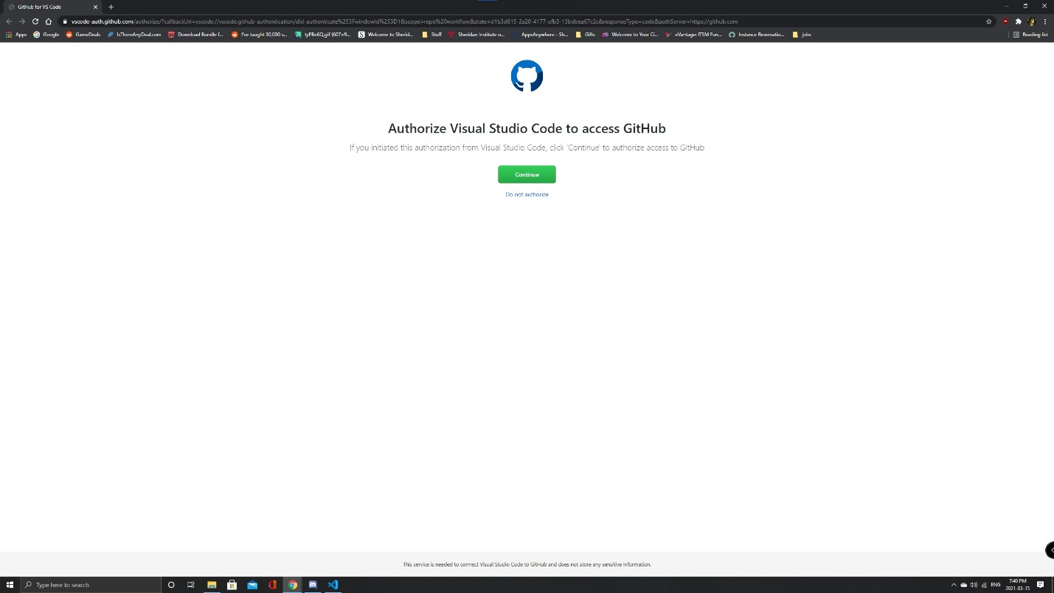 | You will then be brought to this page asking to sign in and asking authorization.  Click on Continue.
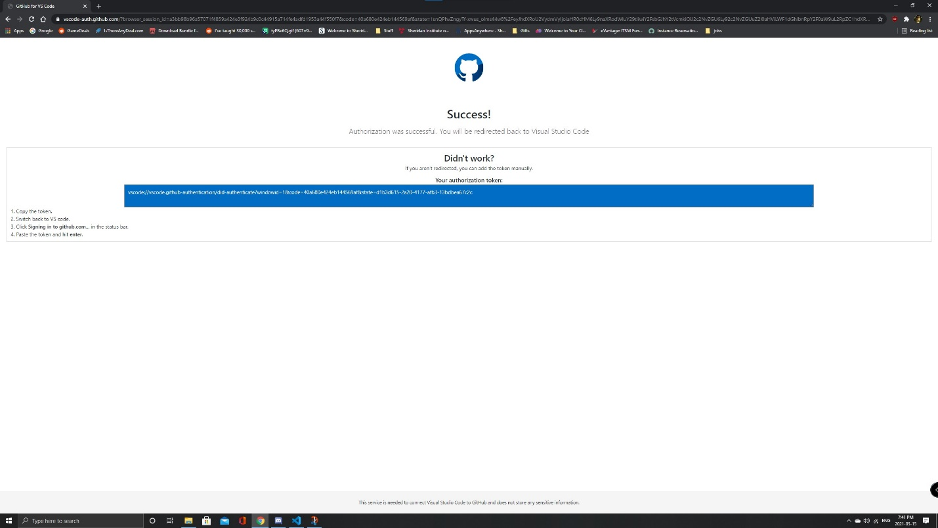 | When successful, you will be brought to this screen.  There will be an option to return directly back to VS Code or entering an authorization token manually.  Select the option to return to VS Code.
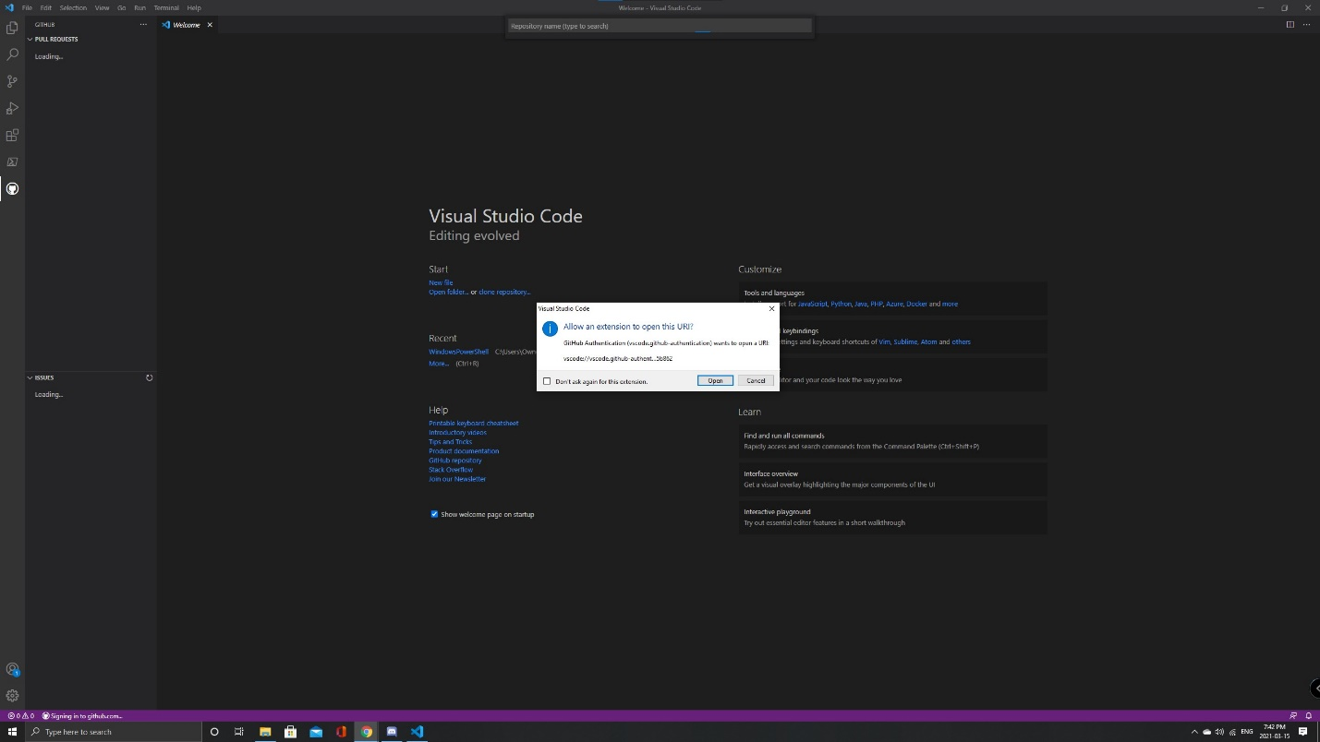 | When brought back to VS Code, Click on Open to allow the extension to open the URL.
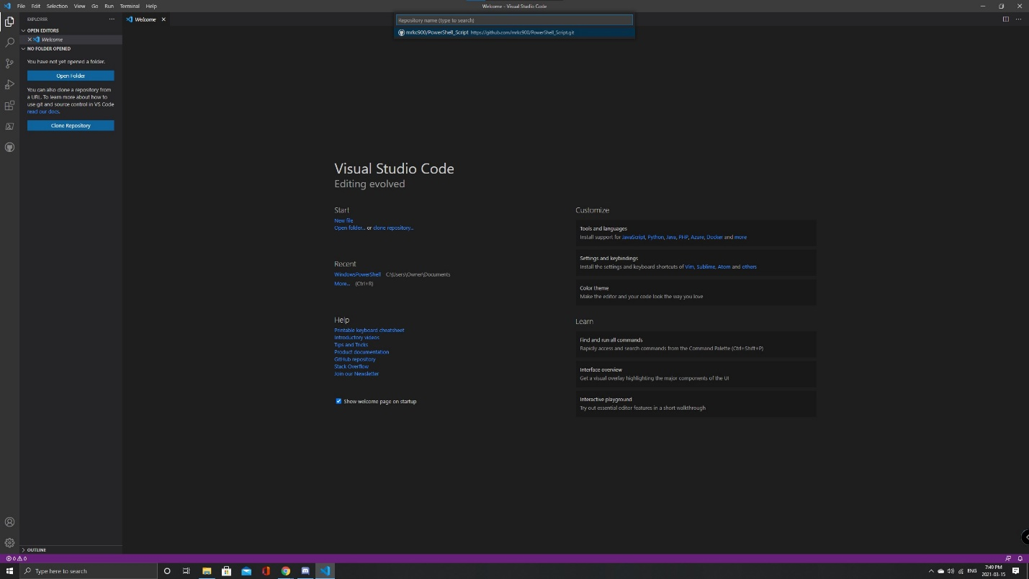 | Once you click open, the search bar at the top will display all the available repositories that is connected to your GitHub Account.  Click on the Repository that was just made.
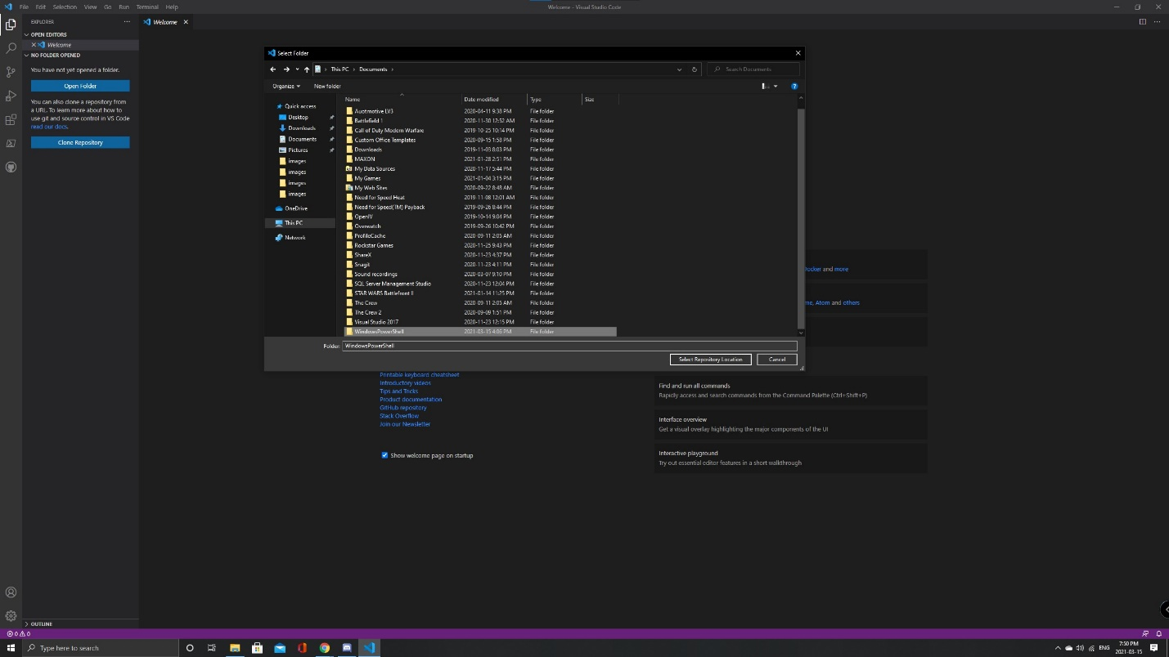 | Select the folder you would like to store the repository location.  I would suggest storing it in the same folder that has the script file from part 3 of this lab.
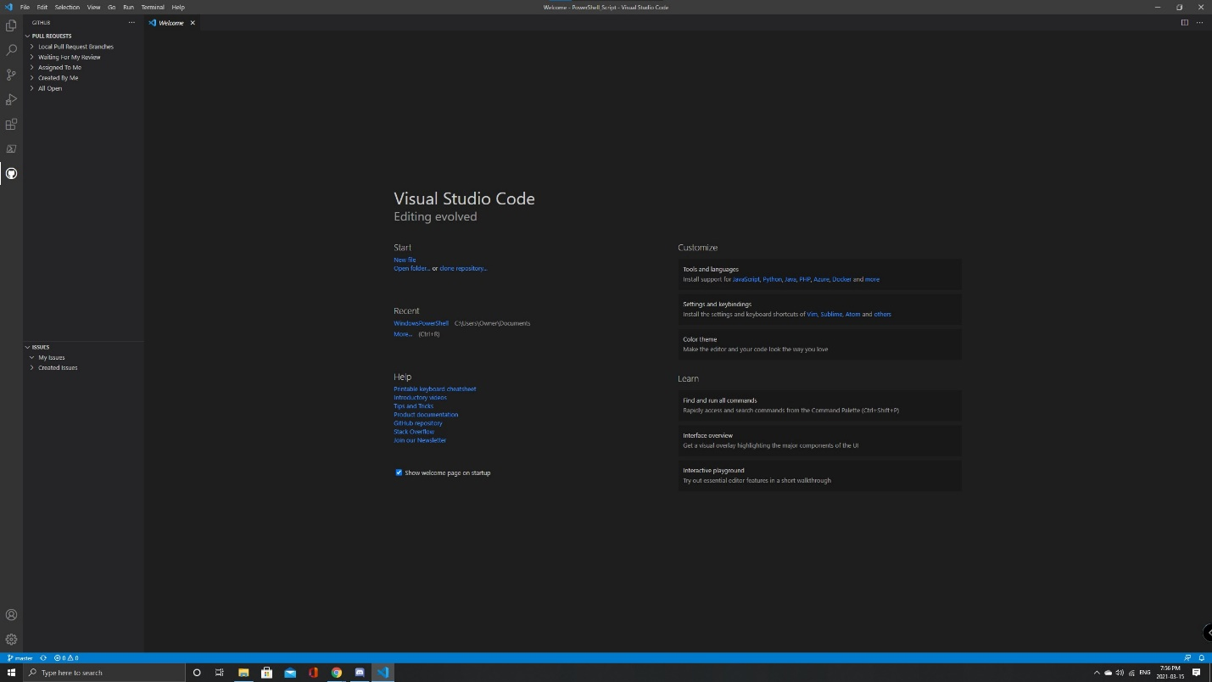 | Once the repository is saved, click on the GitHub icon on the left to make sure you are signed into GitHub.  If you are signed in, you should be able to see these features shown in this image.
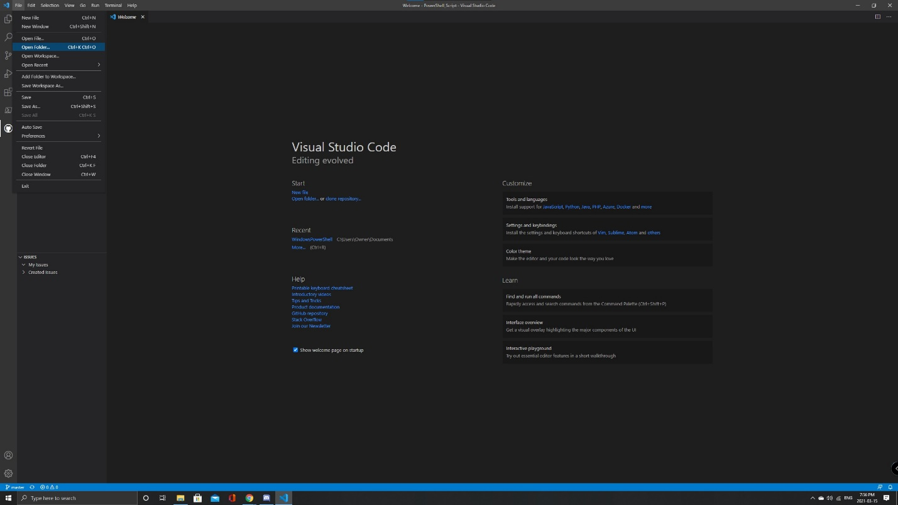 | After making sure that your GitHub account is connected, we will want to open the repository.  To do so, go File>Open folder.
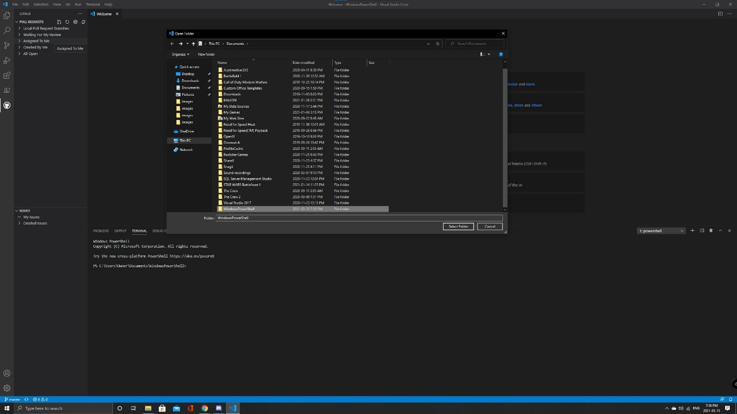 | Navigate to where you saved the repository and open it.
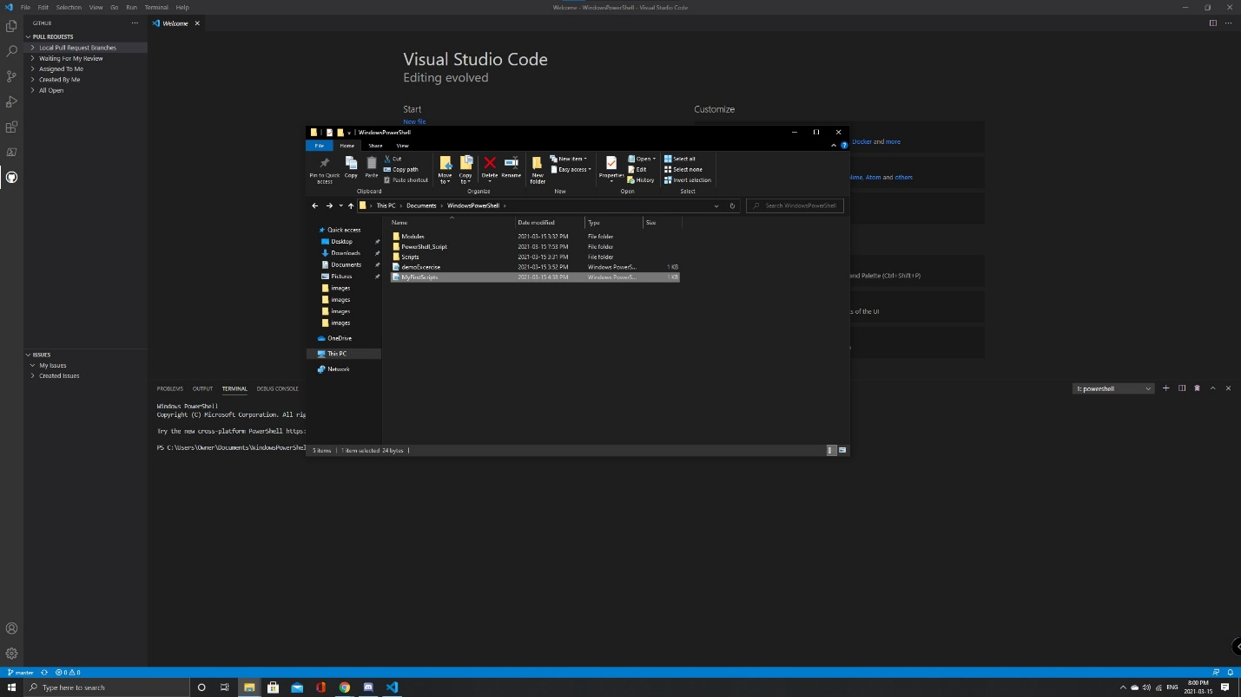 | For this next step, open up the folder that contains the repository and the MyFirstScripts.ps1 file and drag and drop the file into the PowerShell_Script folder.
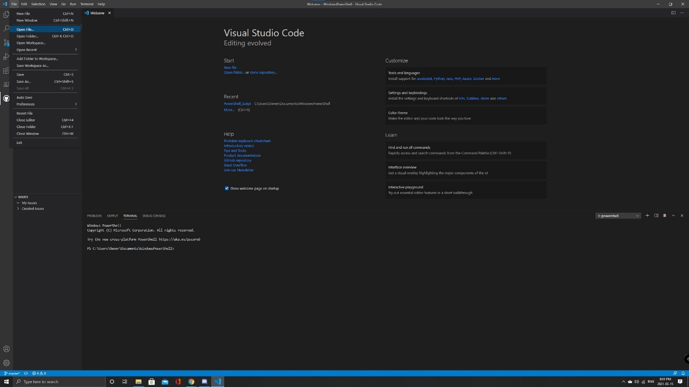 | Once the file is in the repository, we will want to open the file in VS Code.  Go to File>Open file.
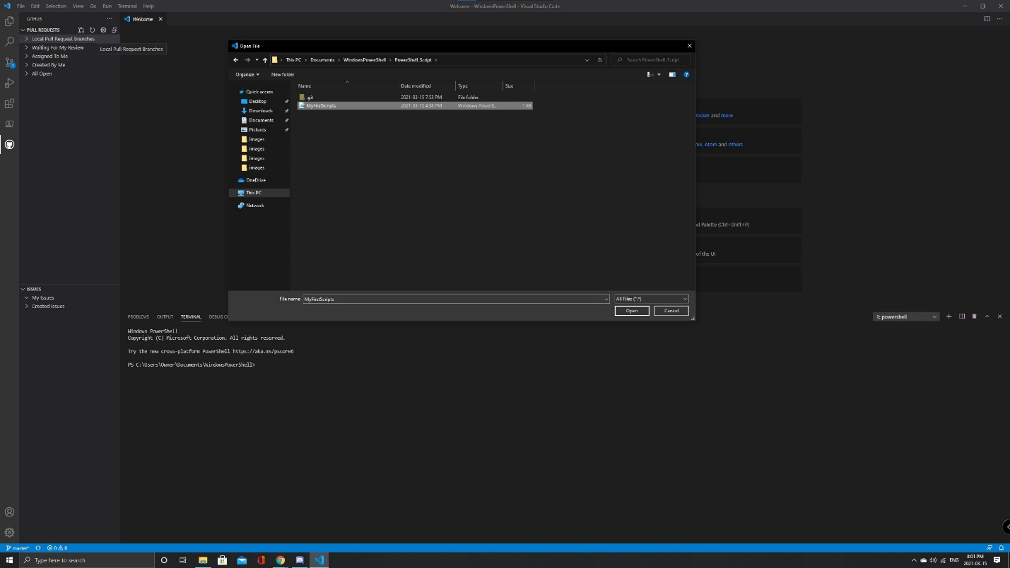 | Navigate to the repository folder and open MyFirstScripts.ps1.
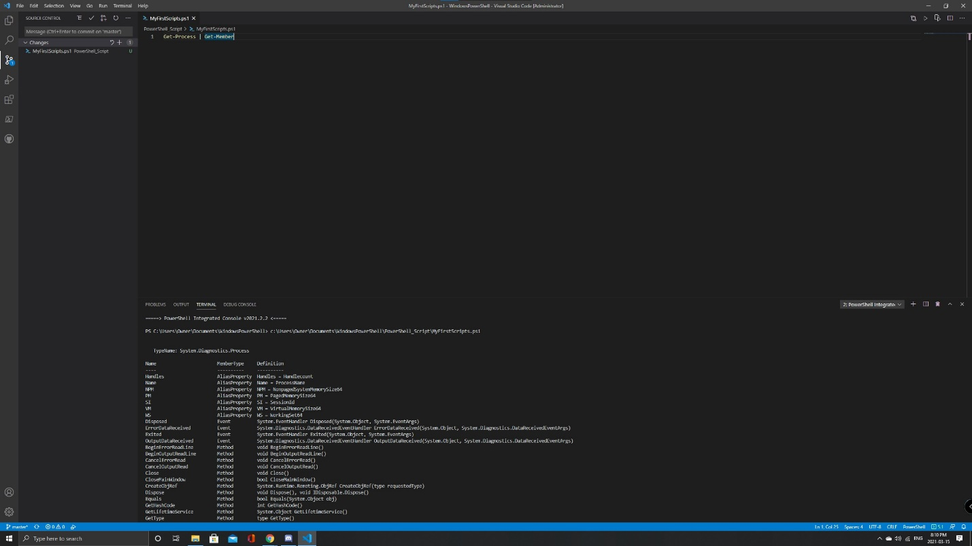 | The file should now open in VS Code, from the PowerShell_Script folder and can be viewed in source control.  Viewing it in source control will indicate the amount of changes that is in the repository and clicking on the icon will show the details of the current repository changes.

